**Approving Activity Logs**

Activity Logs are an important part of AmeriCorps compliance and it is critical that they are reviewed and approved correctly.

When reviewing activity logs, please be sure that the hours listed are actual hours served and do not include lunch breaks or time off.

Below is the process that leaders should be using to approve logs:

1. **When you log in, you will see the time logs that need to be approved on your home page in the alerts section (you may need to scroll down).**

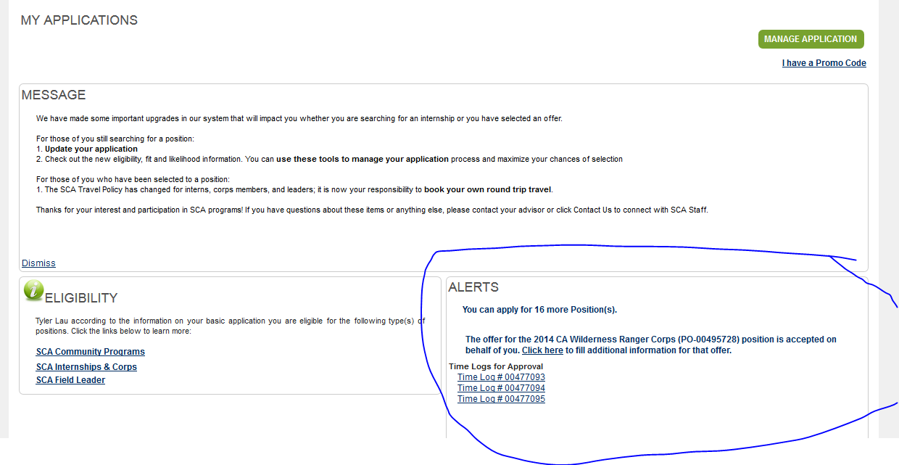

1. **Click on each time log # and it will take you to the time log view.**

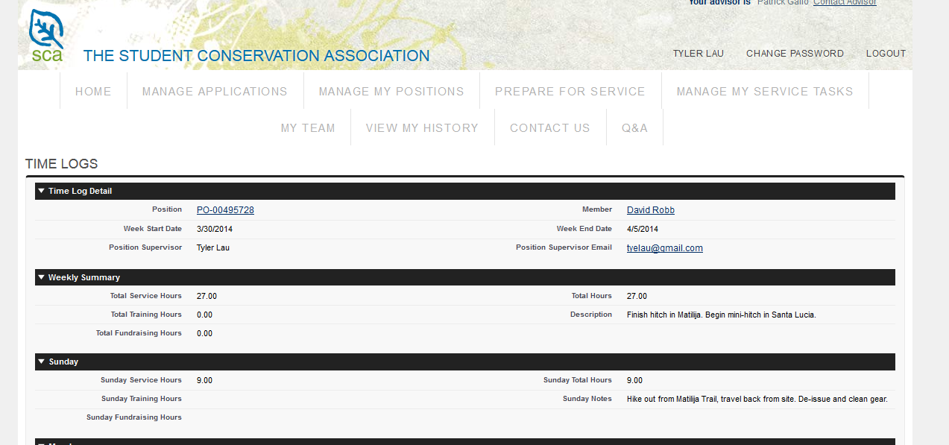

1. **Scroll to the bottom of the page and hit “approve” if it is correct or “reject” if it is not correct.  You should never make changes to a member’s activity logs, this is an AmeriCorps compliance issue that will put SCA at risk in an audit situation.  If the log is incorrect, just click “reject” and ask the member to make the corrections and resubmit it. Once it is resubmitted, you can re-review it and click “approve.”  The audit concerns only apply to activity logs, not output logs.**

