Final Report of 2012 Leader Team
The Student Conservation Association in Partnership with
The New Mexico BLM
Project Leader - Eileen Kazura

Introduction:
The New Mexico BLM hosted a crew of four experienced SCA participants from October 14 to November 22. This crew was able to work in two very different and beautiful locations, El Malpais NCA and the Rio Chama WSA, throughout their five weeks in New Mexico.

The Team:

The 2012 NM BLM I crew members included:
- Kristen Mrozowski – SCA alum from East Lansing, MI
- Joshua Kalfas – SCA project leader alum from Tulsa, OK
- Carly Antilla – SCA alum from sunny Hawaii

These participants were guided by Eileen Kazura, multi-time crew leader for the SCA’s high school program. Eileen came to the crew directly following leading two high school crews in Alaska and participation in a leader crew in the Grand Canyon. She added her own background in trail and restoration work to this crews already deep well of knowledge in these areas.

Conservation Service Outcomes:
- El Malpais: The crew worked on erosion control structures and removing fence from wilderness areas while in El Malpais. Together, this crew and another leader crew completed 17 check dams and took down over 2 miles of fence.

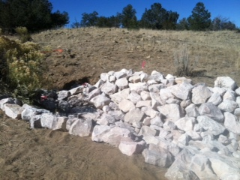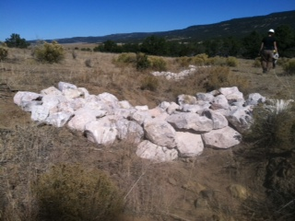

- Rio Chama WSA: The four-person crew installed 8 signs and completed 5 road closures over the course of 7 work days.

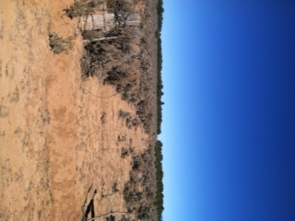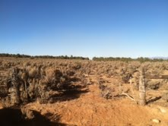

Work Completed:
Check dams completed | 17
Signs installed | 8
Road Closures | 5

Leadership & Professional Development Opportunities:
This crew was able to thrive in an outdoor setting late in the season. We worked together to withstand cold temperatures and even a little snow! At the end of the crew, everyone was able to participate in a crosscut training course set up by the project leader. This course allowed all participants to gain and practice new skills which may come in handy for future SCA endeavors.

Team Highlights:
Highlights include exploring a handful of archaeological sites, including petroglyphs near the campsite in El Malpais. We also learned a lot from BLM specialists who advised us on the building of the check dams. In Rio Chama, the crew enjoyed the beautiful mountain scenery and took pleasure in learning the network of roads of the WSA and closing some of the lesser used.

Opportunities on the Horizon:
The New Mexico BLM is a great place for SCA crews! Hopefully crews will be back in the near future to finish some closures in the Rio Chama and assist with more erosion control in the Cebolla Canyon area of El Malpais.

Thank you:
Much appreciation goes to Ken Jones at El Malpais! His generosity and direction combined to allow the crew to flourish over the 5 weeks. Thanks specifically for loaning out camp gear and tools, as well as dropping by often to check on the work, answer questions and bring mail and kale from the garden. His guidance really made a difference. Thanks also to Tami Torres of the Taos office for coordinating the Rio Chama project.
