Output Log SOP

MySCA Portal
- Current Positions (end date has not passed)
  - Click “Manage My Service Tasks” from the navigation bar
  - Click on the appropriate Position Number (ex. PO-00555555)
  - Continue to Output Log Management
- Closed Positions (end date has passed)
  - Select “View My History” from the navigation bar
  - Click on the appropriate Position Number (ex. PO-00555555)
  - Continue to Output Log Management

Output Log Management
A
A
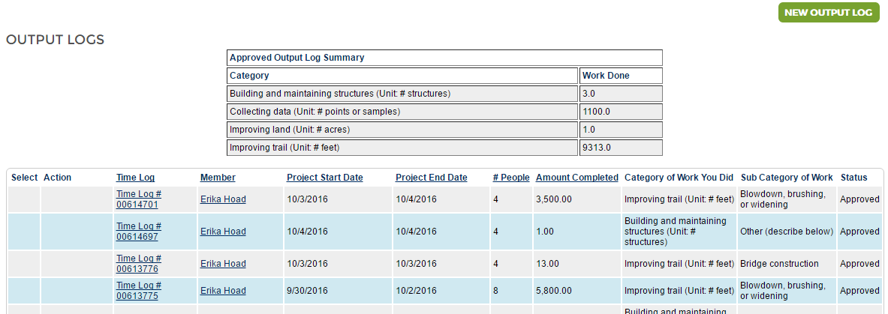
C
B
- New Output Log Button
  - Click to create a new output log
- Approved Output Log Summary
  - Shows a summary of all approved Output Logs
  - Summarizes the total amount completed for each Category of Work
  - Can easily be copied/pasted into a word processor, spreadsheet, etc. to save a copy of your position’s accomplishments
- Output Log List
  - Shows all output logs created for your position
  - Can be sorted by time log number, project start or end date, number of people, or amount completed by clicking on the associated headers.
  - Status Column
    - Draft – Output Log was “saved” by whomever created it but has not be submitted
    - Submitted – Output Log was sent to supervisor for approval
    - Rejected – Output Log needs to be edited and resubmitted to supervisor
    - Approved – Output Log was accepted and will now appear in the summary table
  - Action Column
    - Shows options to submit, edit, or delete output logs (if applicable)

Creating Output Logs
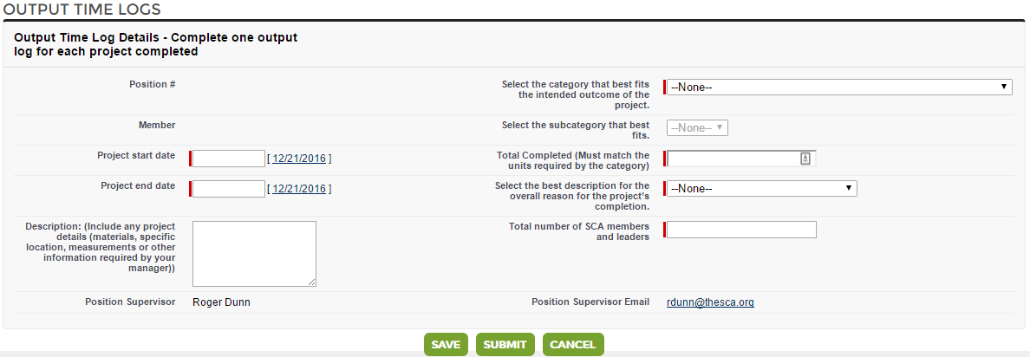
8
7
6
2
1
4
3
5
- Project Start Date
  - Date this specific project began
- Project End Date
  - Date this specific project was completed. Project should be completed before submitting an output log. For the purposes of SCA output logs, we are only interested in the final product and do not need separate logs for all the individual steps of the project.
- Select the category that best fits the intended outcome of the project
  - Use the SCA Project Log for guidance on available categories
  - Remember to consider the bigger picture when choosing the category, what is the intended outcome of the project?
- Select the subcategory that best fits
  - Use the SCA Project Log for guidance on available categories
  - Please avoid using “other” unless no other category/subcategory can possibly fit
- Total Completed (must match units required by the category)
  - Enter a measurement of how much work was accomplished
  - Number MUST be reported in units required by the category
    - Ex. Improving Land requires # acres – do not report # square feet, square meters, hectares, or other area measurements
    - Ex. Improving Trail requires # feet – do not report # miles, meters, yards, or other linear measurements
- Select the best description for the overall reason for the project’s completion.
  - Use the SCA Project Log for guidance on available project impact areas
  - Helps connect projects to the larger conservation issues they are meant to address
- Total number of SCA members and leaders
  - Enter total number of SCA participants working on the project
  - Non-SCA members should not be counted but can be mentioned in the description.
- Description
  - Add any additional project details worth noting including additional information requested by the subcategory headers
- Submit Button
  - Click “submit” to send the Output Log to your supervisor for approval
  - Only use “save” if it is likely the project is incomplete and will need to be updated before submission. Just remember to submit it before the end of your program!

